Exercise-3: Stored Procedures
exercise3.sql
-- Accounts Table
CREATE TABLE Accounts (
AccountID NUMBER PRIMARY KEY,
CustomerName VARCHAR2(100),
AccountType VARCHAR2(20),
Balance NUMBER(10,2)
);

-- Employees Table
CREATE TABLE Employees (
EmployeeID NUMBER PRIMARY KEY,
EmployeeName VARCHAR2(100),
Department VARCHAR2(50),
Salary NUMBER(10,2)
);

-- Inserting Data
INSERT INTO Accounts VALUES (101,'Aditya','Savings',10000);
INSERT INTO Accounts VALUES (102,'Rahul','Savings',15000);
INSERT INTO Accounts VALUES (103,'Priya','Current',20000);
INSERT INTO Accounts VALUES (104,'Neha','Savings',5000);

INSERT INTO Employees VALUES (1,'Amit','IT',50000);
INSERT INTO Employees VALUES (2,'Sneha','IT',60000);
INSERT INTO Employees VALUES (3,'Raj','HR',45000);

COMMIT;

-- Scenario 1:
CREATE OR REPLACE PROCEDURE ProcessMonthlyInterest
AS
BEGIN

UPDATE Accounts
SET Balance = Balance * 1.01
WHERE AccountType = 'Savings';

COMMIT;

END;
/

-- Execution
EXEC ProcessMonthlyInterest;

-- Verification
SELECT * FROM Accounts;

Output (Scenario 1):
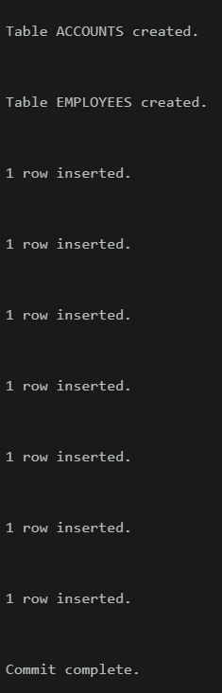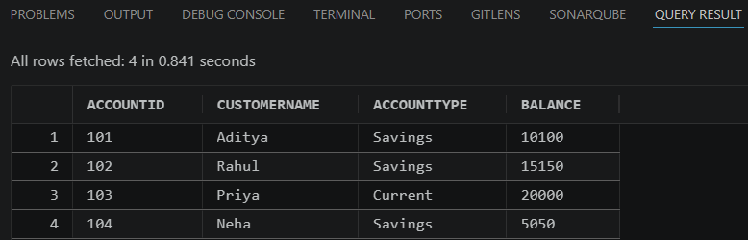

Continued – Scenario 2:
-- Scenario 2:
CREATE OR REPLACE PROCEDURE UpdateEmployeeBonus(
p_department IN VARCHAR2,
p_bonus_percent IN NUMBER
)
AS
BEGIN

UPDATE Employees
SET Salary = Salary +
(Salary * p_bonus_percent / 100)
WHERE Department = p_department;

COMMIT;

END;
/

-- Execution
EXEC UpdateEmployeeBonus('IT',10);

-- Verification
SELECT * FROM Employees;

Output (Scenario 2):
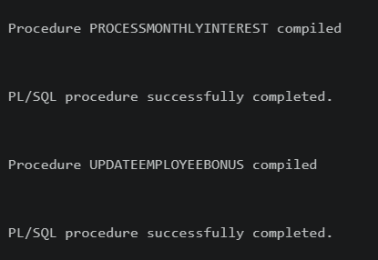
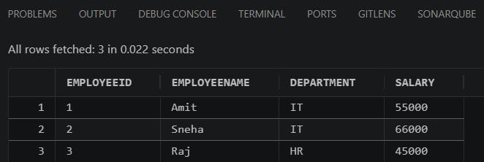

Continued - Scenario 3:
-- Scenario 3:
CREATE OR REPLACE PROCEDURE TransferFunds(
p_from_account IN NUMBER,
p_to_account IN NUMBER,
p_amount IN NUMBER
)
AS
v_balance NUMBER;
BEGIN

SELECT Balance
INTO v_balance
FROM Accounts
WHERE AccountID = p_from_account;

IF v_balance >= p_amount THEN

UPDATE Accounts
SET Balance = Balance - p_amount
WHERE AccountID = p_from_account;

UPDATE Accounts
SET Balance = Balance + p_amount
WHERE AccountID = p_to_account;

COMMIT;

DBMS_OUTPUT.PUT_LINE(
'Transfer Successful'
);

ELSE

DBMS_OUTPUT.PUT_LINE(
'Insufficient Balance'
);

END IF;

END;
/

-- Output
SET SERVEROUTPUT ON;

-- Execution
EXEC TransferFunds(101,102,2000);

-- Verification
SELECT * FROM Accounts;

Output (Scenario 3):
